**Tutorial**

**-Adding simulation model to INA2126**

1. Pick the right part with footprint (DIP-16) as describe in the project.

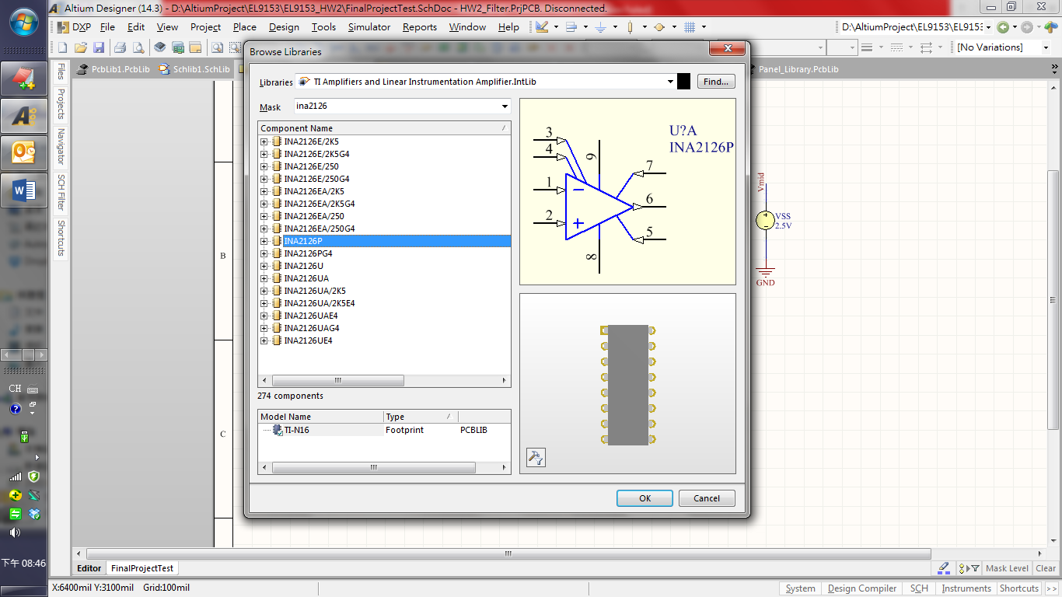

When you are placing this component, it will contains both “U?A” and “U?B” as there are 2 set of instrumentation amplifier in this chip. (For detail, please refer to the datasheet).

1. Double click the “U?A” and add the simulation model

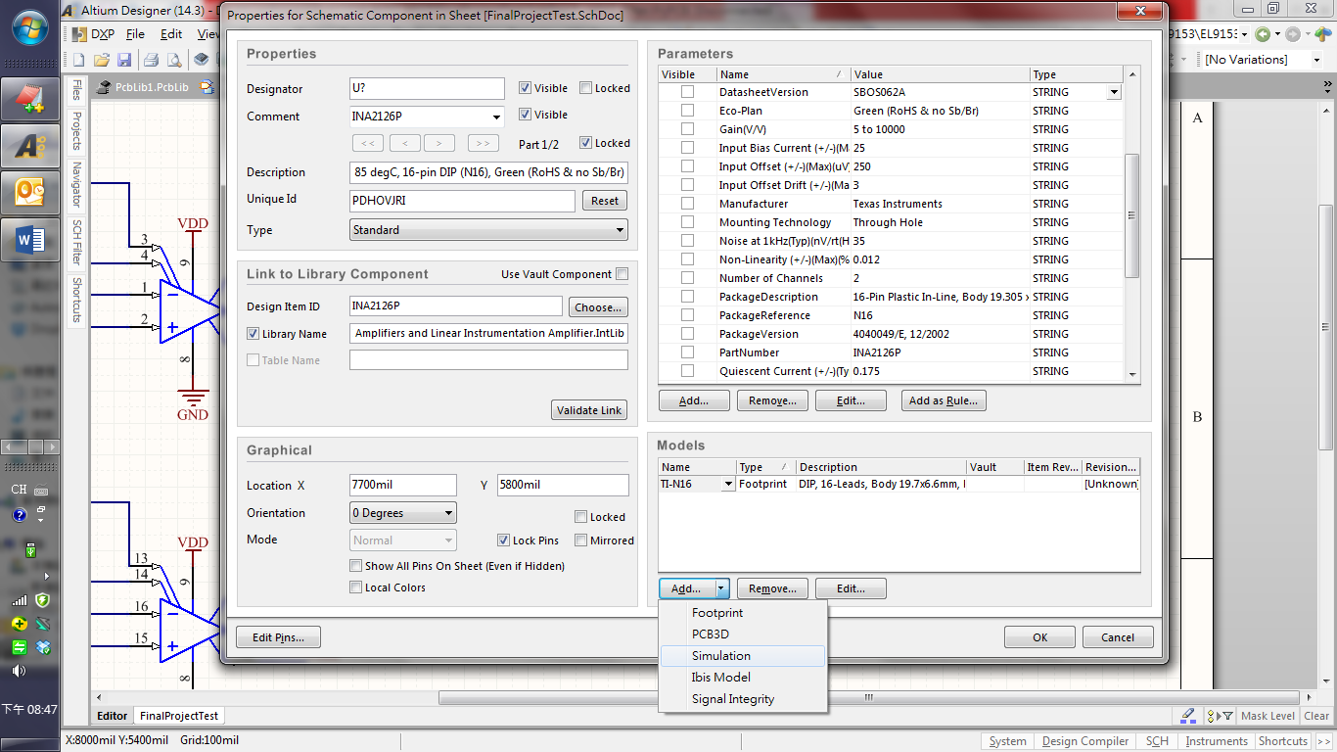

1. Select “Spice Subcircuit”, manually type in “INA2126” in the Model Name section, and click the Full Path to link up your “INA2126.ckt” file

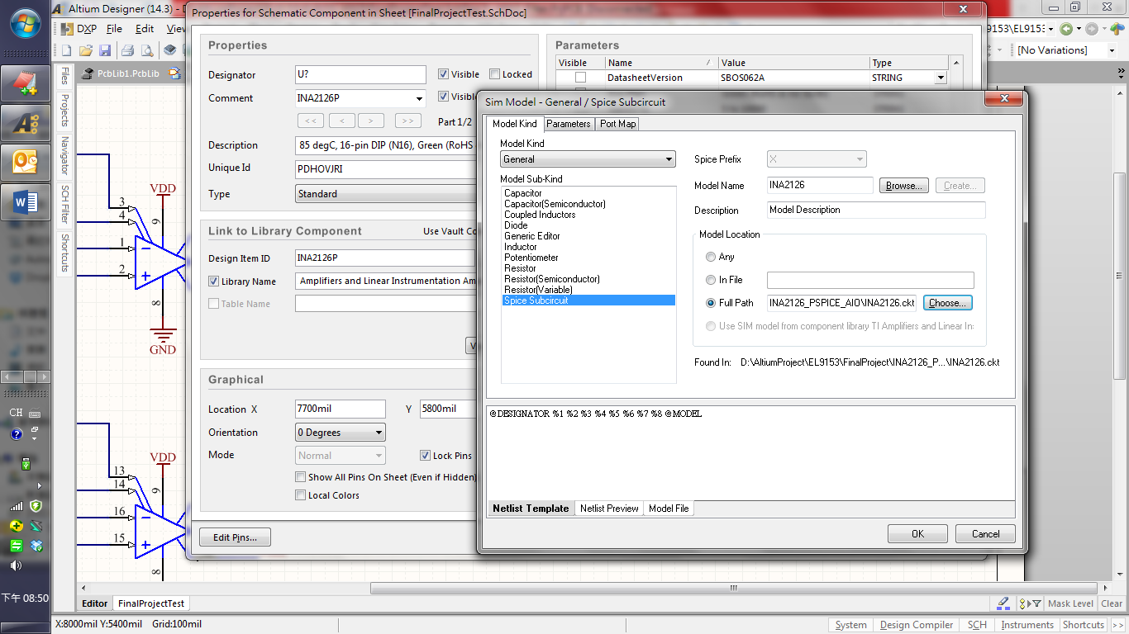

1. Map the model to the schematic according to the model file

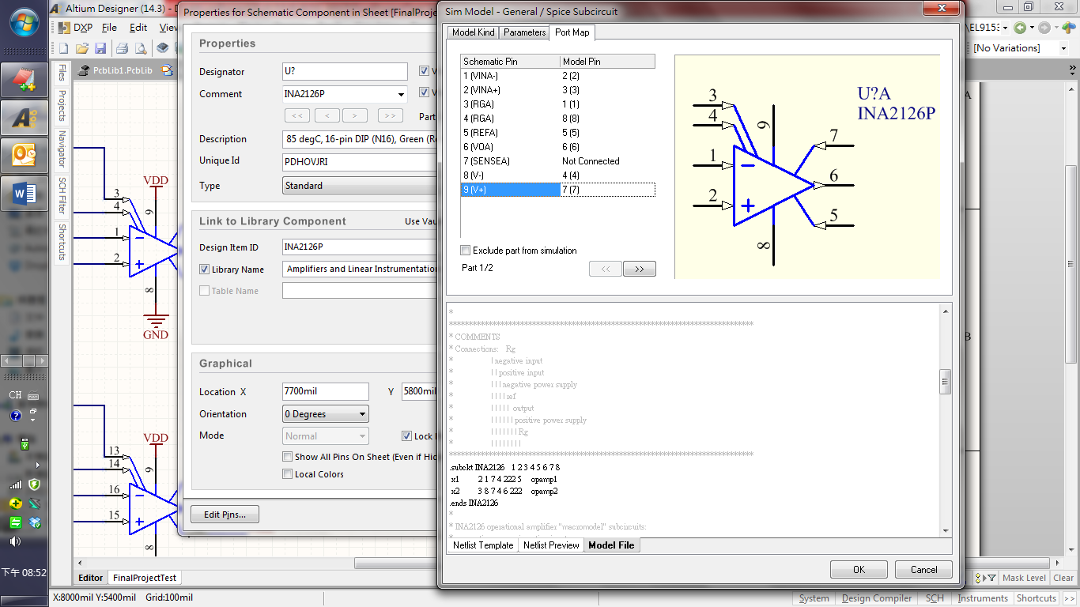

1. Since we are only adding the simulation model to “U?A” right now, disconnect the portion for “U?B”.

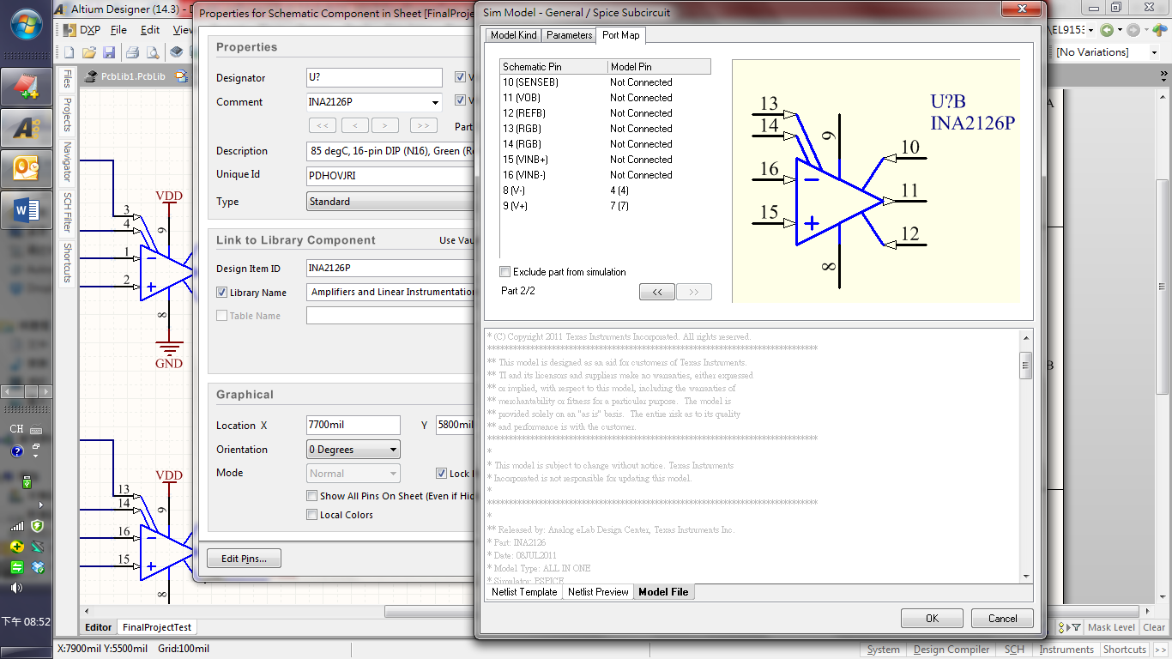

1. Click “OK” and you have successfully added the simulation model to half of the INA2126
2. Repeat step 2-6 but adding the simulation model to “U?B” now.

The Port Map becomes:

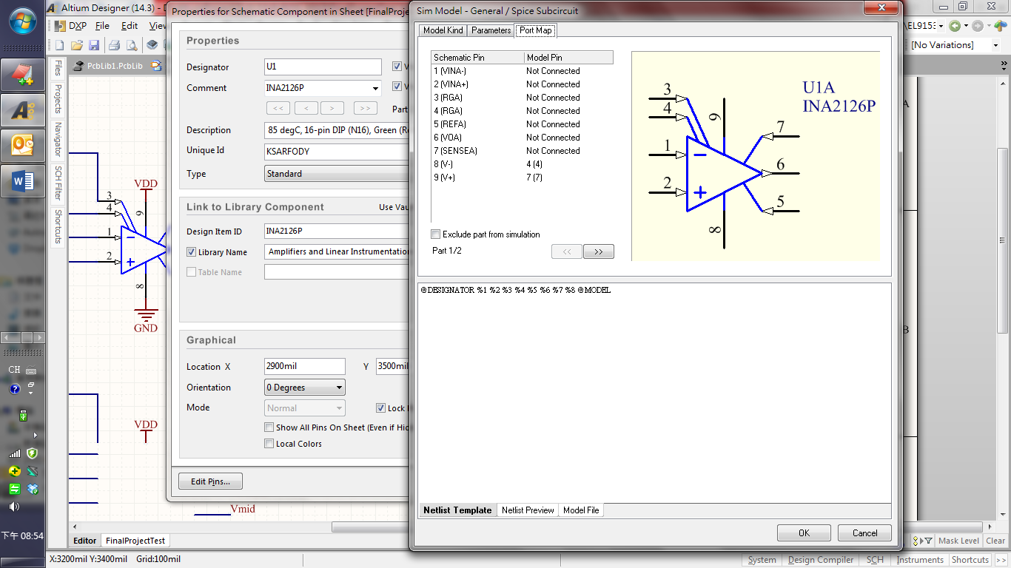

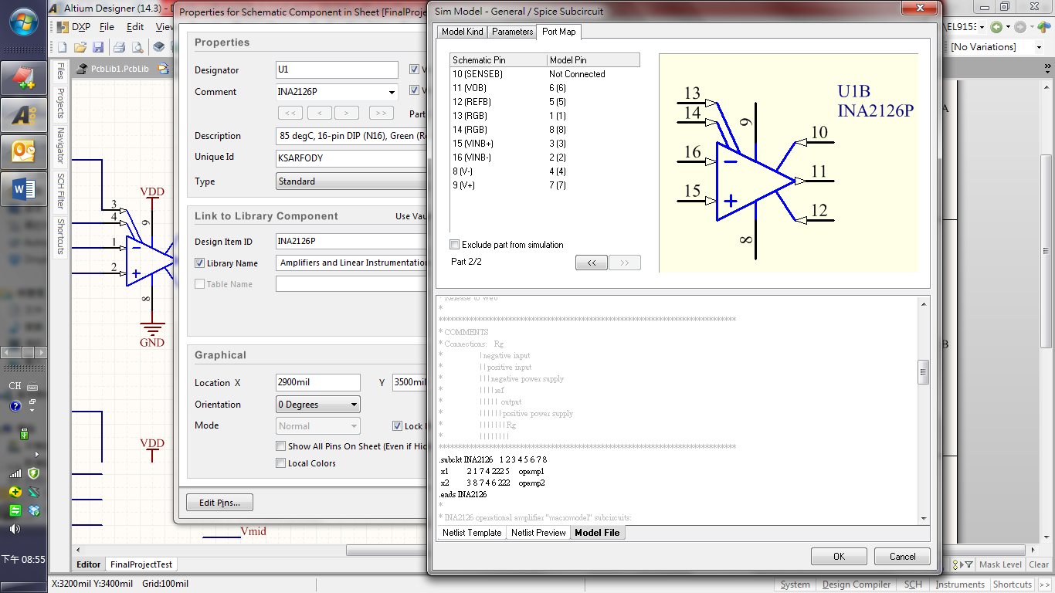

Congratulations!

You may now simulate the INA2126 in your design.